Netherlands Business Visa
  (SCHENGEN STATES) | Embassy of the Netherlands  6/50-F, Shantipath  Chanakyapuri  New Delhi 110 021  Time Taken: 6 - 7 Working Days from the day of Appointment  Embassy Working Days- Monday to Friday
Visa Application Form and Declaration Forms | 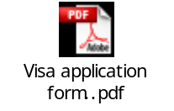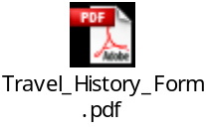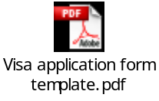

List of Documents required for applying Business Visa.
* All the below mentioned documents should be submitted at once.

- Visa Application (Back to back printed),

- Please sign and submit the authorization form
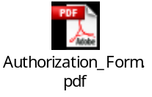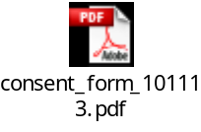

- Valid Passport
- Please double check whether your passport is valid for the period of one year (Mandatory). Pls ensure you are giving all your old passports as well.(20 years passport will not accepted by any of the Schengen countries to apply or to travel)

- Photographs - Two Photographs - (2) latest (more then three months not be accepted) (Photographs - Two recent passport size photographs with glossy finish, 60%-80% face coverage, white background and without border (Size: 35mm x 45mm)

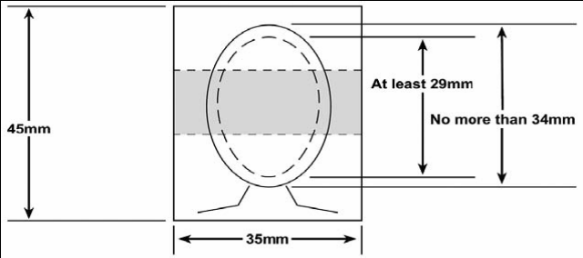

- Invitation letter from Netherlands- Minds should get it from Customer
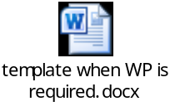

- Latest month pay slip

- Copy of the visas, new passport and old passport first page and last page

Netherland Holiday List - 2015

Date | Day | Holiday
1-Jan | Thursday | New Year Day
26-Jan | Monday | Republic day
6-Mar | Friday | Holi
6-Apr | Monday | Easter
27-Apr | Monday | Kings Day
5-May | Tuesday | Liberation Day
14-May | Thursday | Ascencion Day
25-May | Monday | Whit Monday
2-Oct | Friday | Gandhi Jayanti
22-Oct | Thursday | Dussehra
11-Nov | Wednesday | Diwali
25-Dec | Friday | Christmas Day

